The Worshipful Society of Free Masons

Rough Masons, Wallers, Slaters, Paviors, Plaisterers and Bricklayers

(The Operatives)

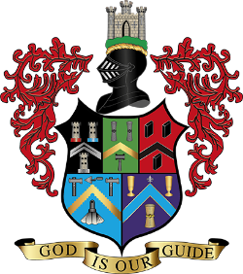

GRACE

TOASTS

*****
THE KING
(Plus Head of State where appropriate)
*****
THE GRAND MASTER MASONS
*****
THE DEPUTY GRAND MASTER MASON
AND MEMBERS OF THE VII°
*****
THE DEPUTY MASTER MASON
*****
THE CANDIDATES (Indentured Apprentices)
*****
VISITORS
*****
OUR NEXT MERRY MEETING
(Seated)

